COMPETITIVE PROGRAMMING

1-Finding Duplicates-O(n^2) Time Complexity,O(1) Space Complexity
Find Duplicate in Array.
Given a read only array of n integers between 1 and n, find one number that repeats.
Input Format:
First Line - Number of elements
n Lines - n Elements
Output Format:
Element x - That is repeated
For example:
Input | Result
5  1 1 2 3 4 | 1
Answer:

#include <stdio.h>

int main() {

int n;

scanf("%d", &n);

int a[n];

for (int i = 0; i < n; i++)

scanf("%d", &a[i]);

for (int i = 0; i < n; i++) {

for (int j = i + 1; j < n; j++) {

if (a[i] == a[j]) {

printf("%d", a[i]);

return 0;

}

}

}

return 0;

}

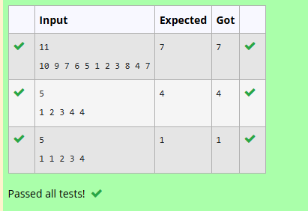

2-Finding Duplicates-O(n) Time Complexity,O(1) Space Complexity
Find Duplicate in Array.
Given a read only array of n integers between 1 and n, find one number that repeats.
Input Format:
First Line - Number of elements
n Lines - n Elements
Output Format:
Element x - That is repeated
For example:
Input | Result
5  1 1 2 3 4 | 1
Answer:

#include <stdio.h>

int main() {

int n;

scanf("%d", &n);

int a[n];

for (int i = 0; i < n; i++)

scanf("%d", &a[i]);

for (int i = 0; i < n; i++) {

for (int j = i + 1; j < n; j++) {

if (a[i] == a[j]) {

printf("%d", a[i]);

return 0;

}

}

}

return 0;

}

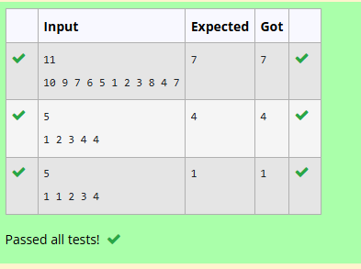

3-Print Intersection of 2 sorted arrays-O(m*n)Time Complexity,O(1) Space Complexity
Find the intersection of two sorted arrays.
OR in other words,
Given 2 sorted arrays, find all the elements which occur in both the arrays.
Input Format
· The first line contains T, the number of test cases. Following T lines contain:
1. Line 1 contains N1, followed by N1 integers of the first array
2. Line 2 contains N2, followed by N2 integers of the second array
Output Format
The intersection of the arrays in a single line
Example
Input:
1
3 10 17 57
6 2 7 10 15 57 246
Output:
10 57
Input:
1
6 1 2 3 4 5 6
2 1 6
Output:
1 6

For example:
Input | Result
1  3 10 17 57  6  2 7 10 15 57 246 | 10 57
Answer:

#include <stdio.h>

int main()

{

int T;

scanf("%d", &T);

while (T--) {

int n1, n2;

scanf("%d", &n1);

int a[n1];

for (int i = 0; i < n1; i++)

scanf("%d", &a[i]);

scanf("%d", &n2);

int b[n2];

for (int i = 0; i < n2; i++)

scanf("%d", &b[i]);

int i = 0, j = 0;

while (i < n1 && j < n2) {

if (a[i] == b[j]) {

printf("%d ", a[i]);

i++;

j++;

}

else if (a[i] < b[j])

i++;

else

j++;

}

printf("\n");

}

return 0;

}

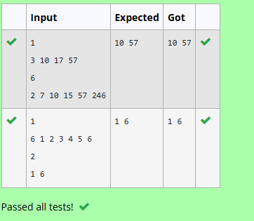

4-Print Intersection of 2 sorted arrays-O(m+n)Time Complexity,O(1) Space Complexity
Find the intersection of two sorted arrays.
OR in other words,
Given 2 sorted arrays, find all the elements which occur in both the arrays.
Input Format
· The first line contains T, the number of test cases. Following T lines contain:
1. Line 1 contains N1, followed by N1 integers of the first array
2. Line 2 contains N2, followed by N2 integers of the second array
Output Format
The intersection of the arrays in a single line
Example
Input:
1
3 10 17 57
6 2 7 10 15 57 246
Output:
10 57
Input:
1
6 1 2 3 4 5 6
2 1 6
Output:
1 6

For example:
Input | Result
1  3 10 17 57  6  2 7 10 15 57 246 | 10 57
Answer:

#include <stdio.h>

int main() {

int T;

scanf("%d", &T);

while (T--) {

int n1, n2;

scanf("%d", &n1);

int a[n1];

for (int i = 0; i < n1; i++)

scanf("%d", &a[i]);

scanf("%d", &n2);

int b[n2];

for (int i = 0; i < n2; i++)

scanf("%d", &b[i]);

int i = 0, j = 0;

while (i < n1 && j < n2) {

if (a[i] == b[j]) {

printf("%d ", a[i]);

i++;

j++;

}

else if (a[i] < b[j]) {

i++;

}

else {

j++;

}

}

printf("\n");

}

return 0;

}
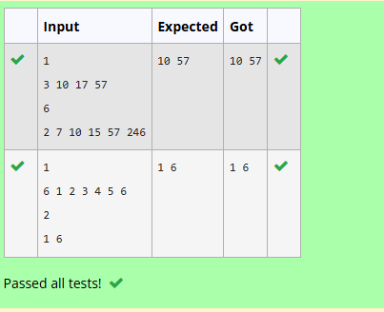

5-Pair with Difference-O(n^2)Time Complexity,O(1) Space Complexity]
Given an array A of sorted integers and another non negative integer k, find if there exists 2 indices i and j such that A[j] - A[i] = k, i != j.
Input Format:
First Line n - Number of elements in an array
Next n Lines - N elements in the array
k - Non - Negative Integer
Output Format:
1 - If pair exists
0 - If no pair exists
Explanation for the given Sample Testcase:
YES as 5 - 1 = 4
So Return 1.

For example:
Input | Result
3  1 3 5  4 | 1
Answer:

#include <stdio.h>

int main() {

int n, k;

scanf("%d", &n);

int a[n];

for (int i = 0; i < n; i++)

scanf("%d", &a[i]);

scanf("%d", &k);

int i = 0, j = 1;

while (j < n) {

int diff = a[j] - a[i];

if (diff == k) {

printf("1");

return 0;

}

else if (diff < k) {

j++;

}

else {

i++;

}

if (i == j)

j++;

}

printf("0");

return 0;

}
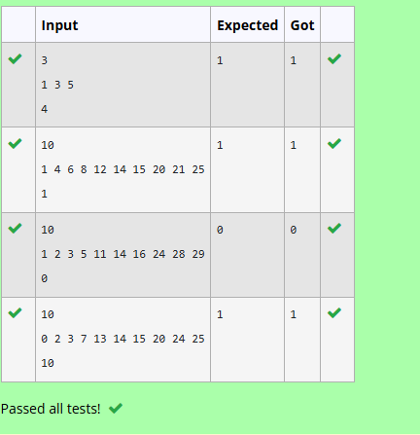

6-Pair with Difference -O(n) Time Complexity,O(1) Space Complexity
Given an array A of sorted integers and another non negative integer k, find if there exists 2 indices i and j such that A[j] - A[i] = k, i != j.
Input Format:
First Line n - Number of elements in an array
Next n Lines - N elements in the array
k - Non - Negative Integer
Output Format:
1 - If pair exists
0 - If no pair exists
Explanation for the given Sample Testcase:
YES as 5 - 1 = 4
So Return 1.

For example:
Input | Result
3  1 3 5  4 | 1
Answer:
#include <stdio.h>
int main() {
int n, k;
scanf("%d", &n);
int a[n];
for (int i = 0; i < n; i++)
scanf("%d", &a[i]);
scanf("%d", &k);
int i = 0, j = 1;
while (i < n && j < n) {
if (i == j) {
j++;
continue;
}

if (a[j] - a[i] == k) {
printf("1");
return 0;
}

if (a[j] - a[i] < k)
j++;
else
i++;
}
printf("0");
return 0;
}
